**Introduction to Computing**

**(LAB)**

**Topic: Conditional Statement (Variables Inputs , switch-case)**

# Objectives

* Understand and apply conditional statements (Variables Inputs, switch-case) in C++.
* Build logical thinking through problem-solving tasks involving decision-making.
* Enhance programming skills by implementing various conditional structures in practical scenarios.

# Outcomes

* - Students will be able to write C++ programs using different types of conditional statements.
* - Students will be able to analyze problems and apply the appropriate conditional logic.
* - Students will demonstrate the ability to create and test programs that require decision-making processes.

# Content Overview

**1.** **Introduction to Conditional Statements**  
 - Overview of selection structures: `if`, `if-else`.  
 - Syntax explanation with examples.  
**2. Tasks:**  
 - Practical programming tasks that cover input handling, condition checking, and output generation.  
 - Tasks include programs for calculating averages, checking character cases, finding maximum values, and simulating a simple calculator.  
**3. Sample Outputs:**  
 - Provided outputs for each task to illustrate expected results.  
**4. Bonus Problems:**  
 - Advanced tasks such as outputting digits of a number in words and implementing BMI and weight calculators.

# Instructions

**1. Task Implementation:**  
 - Use any C++ IDE to write and test the programs.  
 - Follow the syntax and structure guidelines provided in the document for each type of conditional statement.  
**2. Program Testing:**  
 - Run each program with different inputs to ensure correct logic implementation.  
 - Verify output matches the provided sample outputs.  
**3. Submission:**  
 - Save all programs in separate files named by task (e.g., `task1.cpp`, `task2.cpp`).  
 - Submit the completed tasks by uploading them to the designated submission platform.

|  |  |
| --- | --- |
| **Selection:**  In selection, the program executes particular statements depending on some conditions. There are multiple selection statements: | |
| **if:**  syntax:  if(expression)  {  Body of if(statement);  }  In this selection statement a set of instruction are dependent on the condition/expression of selection statement if condition/expression is true body of selection statement will be executed. If condition/expression is false body of selection statement will be skipped and next instructions which are defined after selection statement will be executed. | **if else:**  syntax:  if(expression)  {  Body of if(statement);  }  else  {  Body of else(statements);  }  In this selection statement a set of instruction are dependent on the condition/expression of selection statement if condition/expression is true body of selection statement will be executed. If condition/expression is false body of selection statement will be skipped and body of else will be executed. Else part doesn’t have any condition/expression. |

|  |
| --- |
| **🡪 if else if: (additional just for your knowledge)**  syntax:  if(expression)  {  Body of if(statement);  }  else if(expression)  {  Body of else(statements);  }  In this selection statement a set of instruction are dependent on the condition/expression of selection statement if condition/expression is true body of selection statement will be executed. If condition/expression is false, then next selection statement’s condition/expression will be tested and so on. If any of the selection statement is tested as true than no further statement will be test and the control of program will be shifted after those selection statement. |

## **Lab Tasks:**

## **Task 1:**

Write a C++ program that inputs price and quantity of the following items and print the total value. The items are **Wheat, Rice & Sugar. (Value = Price * Quantity)**

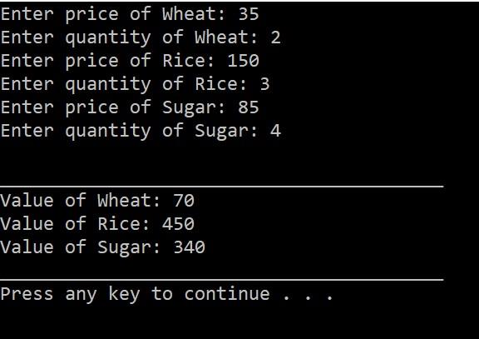

## **Task 2**

Create a program to Print month Name using Switch Cases

**Hint:**

If user enter month 5 it display “May”.

Default “input is invalid”

## **Task 3**

Write a cpp calculator program that takes two numbers and an operator as input and performs the corresponding arithmetic operation using a switch statement.

**Sample Output:**

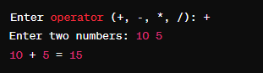

## **Task 4**

Write a cpp program that takes a score as input and prints the corresponding grade using a switch statement.

**Sample Output:**

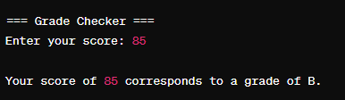

## **Task 5**

Create a program where the user inputs a number (1–7) and the program outputs the corresponding day of the week (e.g., 1 for "Monday", 2 for "Tuesday", etc.) using switch.

## **Task 6**

**Simple Greeting Program**:

Write a program that takes a time range as input (e.g., 1 for "Morning", 2 for "Afternoon", 3 for "Evening", 4 for "Night") and uses switch to display a corresponding greeting message.